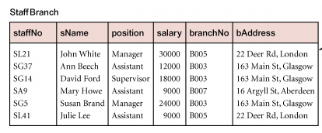
Relations with data redundancy suffer from update anomalies, which can be classified as insertion, deletion, and modification anomalies. This can be exhibited in the above diagram; a very simple Staff Branch relation which includes information about staff name, position, salary, branch and address of the Branch. We will assume that the database designed didn’t undertake the necessary steps of normalization, and kept the following data organized in the above relation as specified. In this case, if we were to delete StaffNo = ‘SA9’, we will also delete the corresponding entry of the BranchNo = B007 and its corresponding address. In this case, information regarding that particular branch will also be lost and this information will no longer be contained within the system. The deletion anomaly has been demonstrated in the following; and can be overcome with the process of normalization(decomposition); in this case, it would be more suitable to have two relations:
- Staff Relation
- Branch Relation

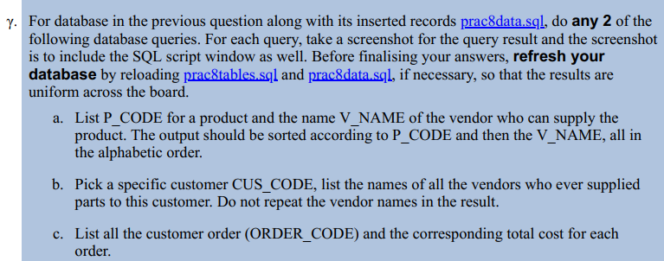
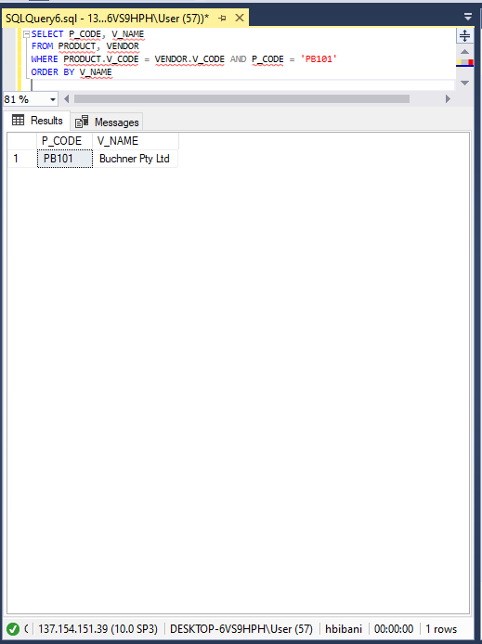
A.

SELECT P_CODE, V_NAME
FROM PRODUCT, VENDOR
WHERE PRODUCT.V_CODE = VENDOR.V_CODE AND P_CODE = 'PB101'
ORDER BY V_NAM

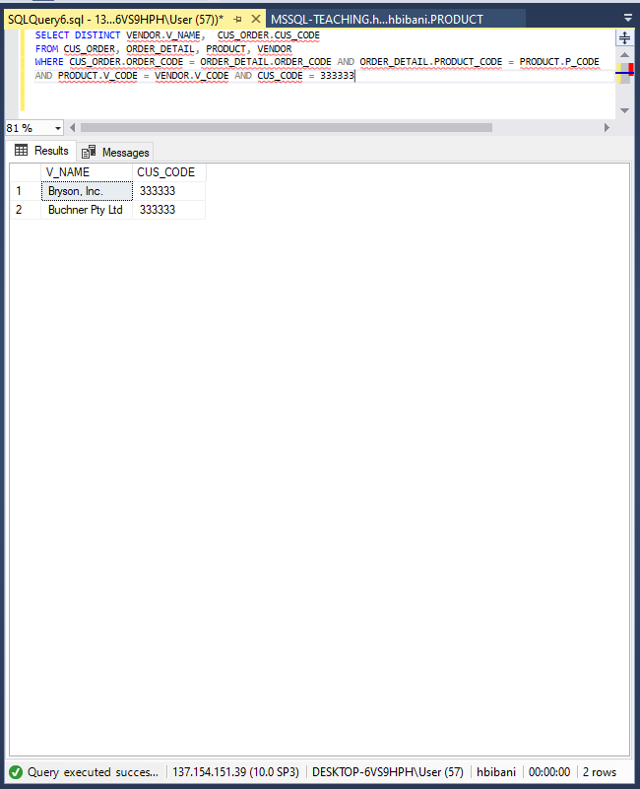
B.

SELECT DISTINCT VENDOR.V_NAME, CUS_ORDER.CUS_CODE
FROM CUS_ORDER, ORDER_DETAIL, PRODUCT, VENDOR
WHERE CUS_ORDER.ORDER_CODE = ORDER_DETAIL.ORDER_CODE AND ORDER_DETAIL.PRODUCT_CODE = PRODUCT.P_CODE
AND PRODUCT.V_CODE = VENDOR.V_CODE AND CUS_CODE = 333333

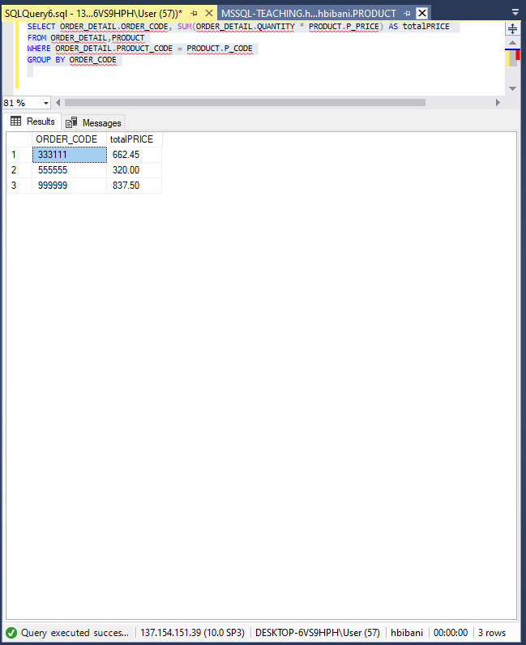
C.

SELECT ORDER_DETAIL.ORDER_CODE, SUM(ORDER_DETAIL.QUANTITY * PRODUCT.P_PRICE) AS totalPRICE
FROM ORDER_DETAIL,PRODUCT
WHERE ORDER_DETAIL.PRODUCT_CODE = PRODUCT.P_CODE
GROUP BY ORDER_CODE

